Project Screenshots
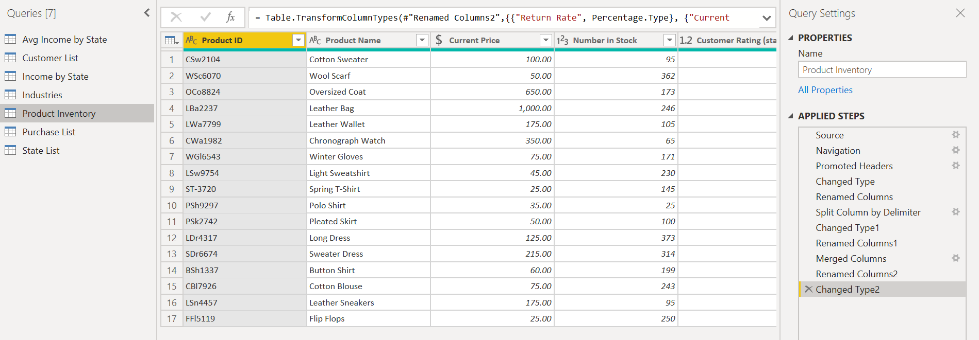
- Screenshots of Product Inventory Table and Applied Steps

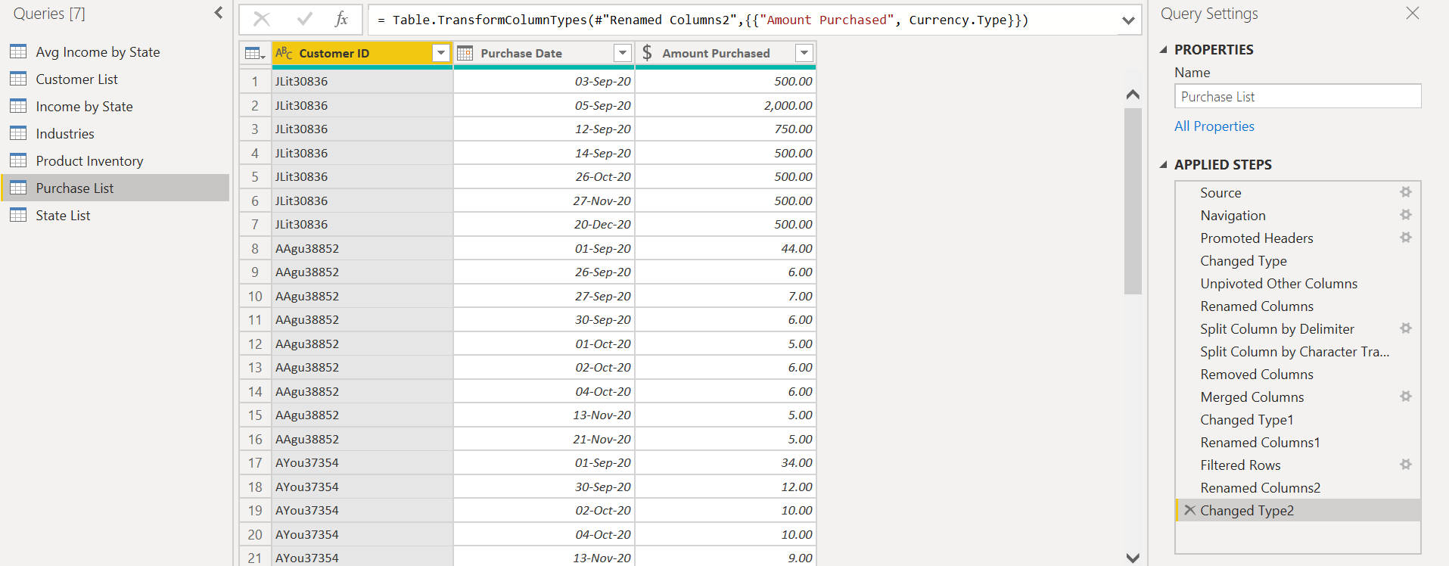
- Screenshots of Purchase List Table and Applied Steps

- Screenshot of DAX formula – Income category
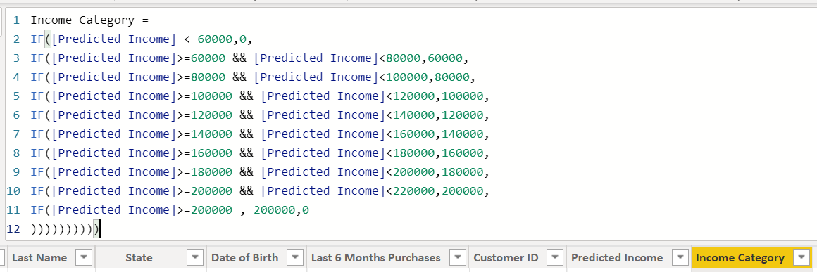
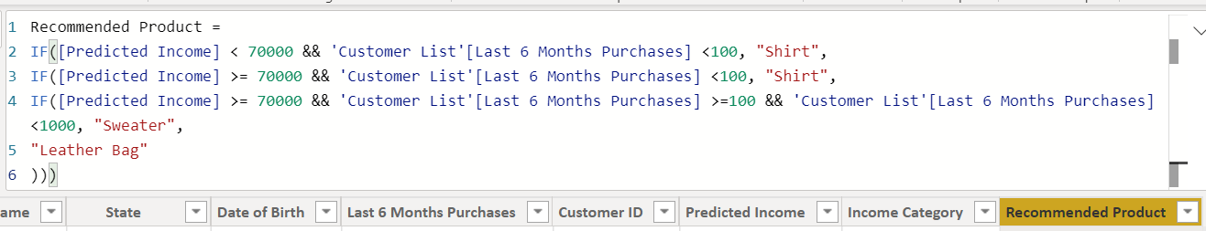
- Screenshot of DAX formula – Product Recommendation

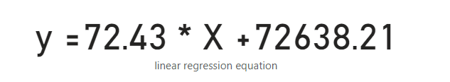
- Screenshot of the formula used to predict customer incomes based on the linear regression of sales and income

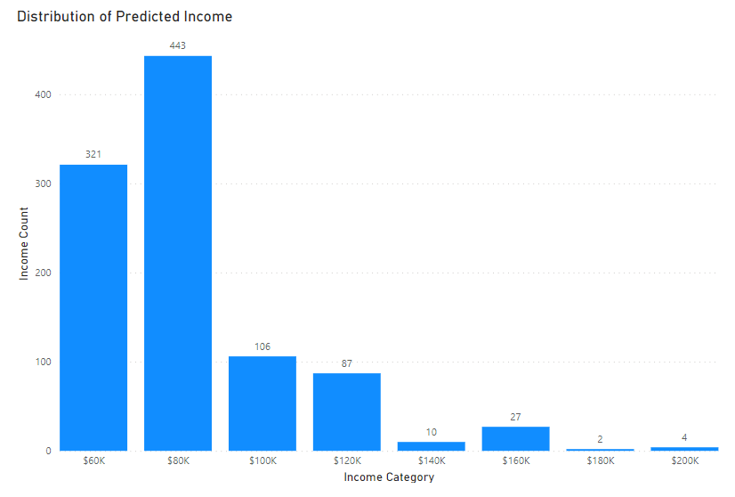
- Screenshot of histogram – Distribution and shape of predicted income

- Screenshot of scatterplot and card
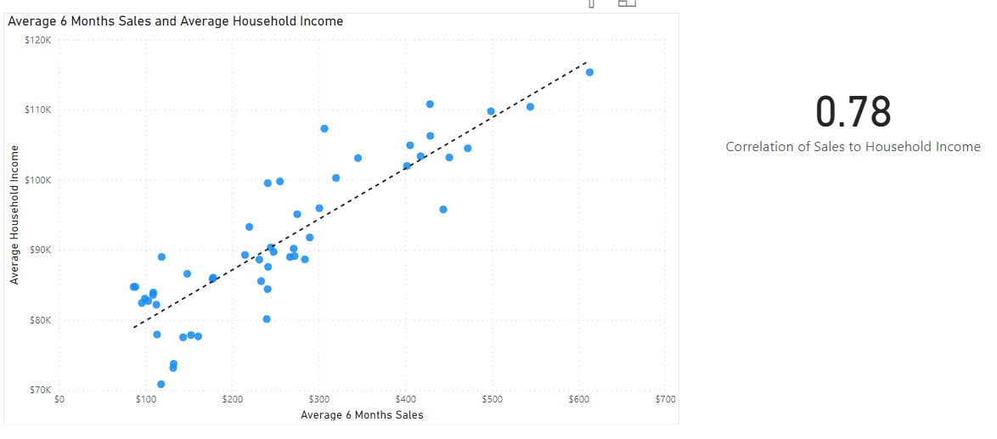
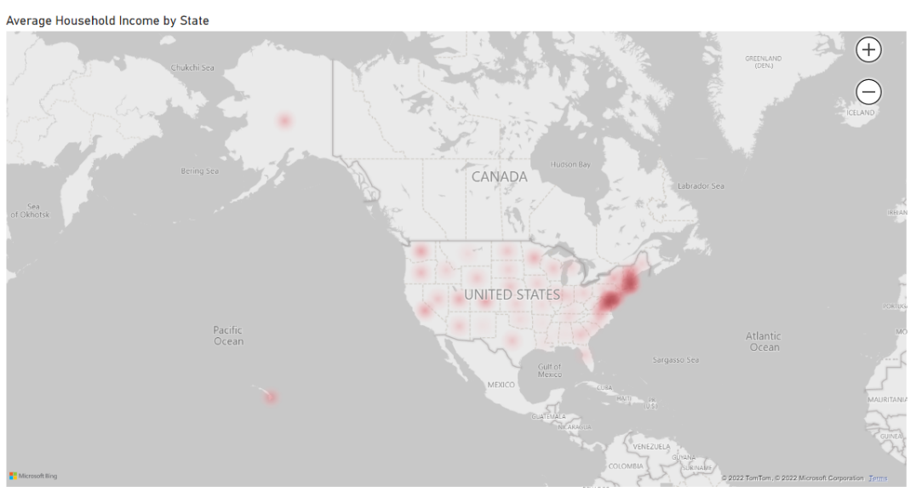
- Screenshot of the heatmap – Average household income by state

- Screenshots of cross-filter
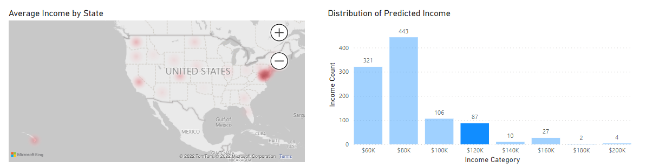
  - Screenshot of cross-filtered histogram and heatmap

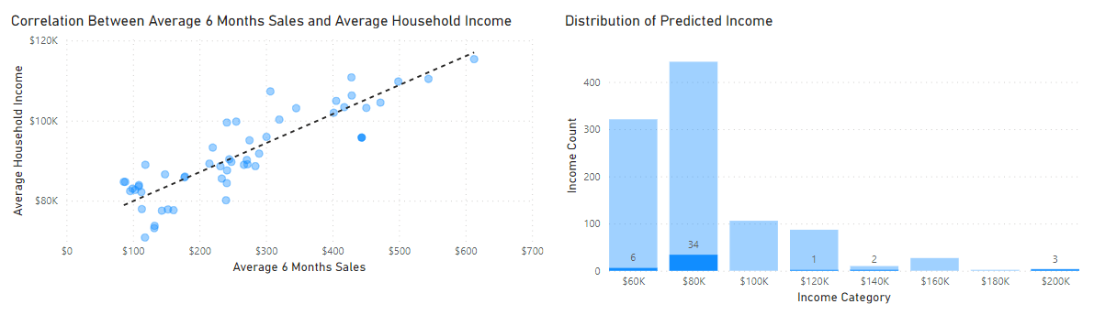
  - Screenshot of cross-filtered scatterplot and histogram

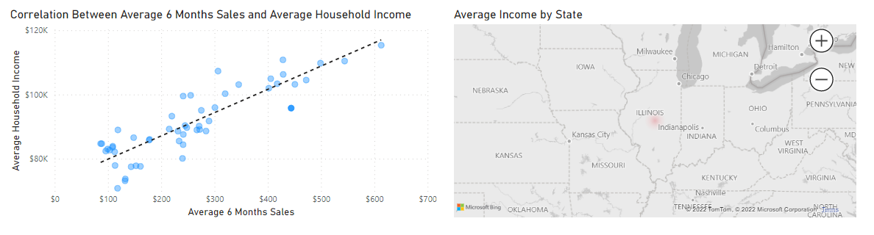
  - Screenshot of cross-filtered scatterplot and heatmap

